**Project Design Phase-I**

**Solution Architecture**

|  |  |
| --- | --- |
| Date | 17 October 2022 |
| Team ID | PNT2022TMID45949 |
| Project Name | **Project** - Emerging Methods for Early Detection of Forest Fires |
| Maximum Marks | 4 Marks |

**Solution Architecture:**

* Forest fires are a major environmental issue, creating economic and ecological damage while endangering human lives.
* There are typically about 100,000 wildfires in the United States every year. Over 9 million acres of land have been destroyed due to treacherous wildfires.
* It is difficult to predict and detect Forest Fire in a sparsely populated forest area and it is more difficult if the prediction is done using ground-based methods like Camera or Video-Based approach.
* Satellites can be an important source of data prior to and also during the Fire due to its reliability and efficiency.
* The various real-time forest fire detection and prediction approaches, with the goal of informing the local fire authorities.

**Example - Solution Architecture Diagram:**

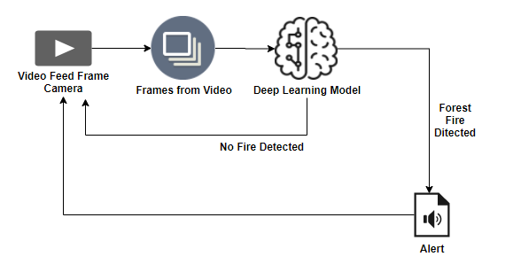

Figure 1: Architecture and data flow of the voice patient diary sample application

**Reference: https://core.ac.uk/download/pdf/228547541.pdf**